**Restaurant & Food Analysis Projects**

1. **Swiggy Data Analysis** – Analyze restaurant ratings, delivery times, and customer preferences.
2. **Uber Eats Insights** – Study customer ordering patterns and peak order times.
3. **Food Delivery Cost Analysis** – Compare prices of similar dishes across different platforms.
4. **Healthy Food Recommendation System** – Suggest restaurants based on health-conscious choices.
5. **Street Food vs Fine Dining: A Comparative Study** – Analyze cost, ratings, and popularity.

**E-Commerce & Retail Analysis Projects**

1. **Amazon Product Review Analysis** – Analyze customer sentiment and best-rated products.
2. **Flipkart Sales Data Analysis** – Study product pricing trends and customer buying behavior.
3. **Grocery Store Insights** – Compare online vs. offline grocery purchases.
4. **Supermarket Sales Prediction** – Predict future sales using past transaction data.
5. **Local Market vs Online Shopping** – Compare pricing, availability, and customer preference.

**Social Media & Customer Behavior Analysis**

1. **Twitter Sentiment Analysis on Food Delivery Services** – Find out how people feel about food delivery apps.
2. **Instagram Trends in Food Blogging** – Study how food influencers affect restaurant popularity.
3. **YouTube Restaurant Review Analysis** – Extract insights from restaurant review videos.
4. **Customer Complaints Analysis on Online Platforms** – Identify common issues in online ordering services.
5. **Sentiment Analysis of Google Reviews for Restaurants** – Categorize restaurant reviews into positive, neutral, and negative.

**Travel & Hospitality Industry Projects**

1. **Hotel Booking Data Analysis** – Study the impact of pricing and ratings on hotel bookings.
2. **Airbnb Pricing Prediction** – Predict the price of Airbnb listings based on location and amenities.
3. **Tourism Trends in Popular Destinations** – Analyze tourist preferences and seasonal trends.
4. **Cab Service Demand Analysis (Ola/Uber)** – Study peak hours, ride pricing, and customer demand.
5. **Metro City vs Small Town Food Trends** – Compare food preferences based on location data.

**1. Healthcare & Medical Analysis**

1. **Hospital Patient Admission Trends** – Analyze patient inflow based on seasons and diseases.
2. **Disease Prediction using Symptoms Data** – Use machine learning to predict illnesses.
3. **COVID-19 Data Analysis** – Study the impact of COVID-19 across different countries.
4. **Medical Insurance Claim Analysis** – Identify fraud patterns in insurance claims.
5. **Pharmaceutical Drug Sales Analysis** – Find trends in medicine sales across regions.

**2. Education & Student Performance**

1. **Student Exam Performance Analysis** – Study factors affecting student grades.
2. **Online Learning vs Offline Learning: A Comparative Study** – Analyze effectiveness of both modes.
3. **School Dropout Rate Analysis** – Identify reasons behind student dropouts.
4. **Library Book Borrowing Trends** – Analyze which books are borrowed the most in a library.
5. **Career Path Prediction for Students** – Use survey data to recommend career paths.

**3. Sports & Entertainment**

1. **IPL Cricket Data Analysis** – Analyze team performance over the years.
2. **Football Match Prediction** – Predict match outcomes using past data.
3. **Movie Box Office Prediction** – Use data to predict a movie’s success.
4. **Netflix Viewing Trends** – Find the most popular genres and watch times.
5. **Music Streaming Behavior** – Analyze how people consume music across different platforms.

**4. Finance & Banking**

1. **Stock Market Price Prediction** – Use historical stock data for predictions.
2. **Credit Card Fraud Detection** – Identify patterns in fraudulent transactions.
3. **Loan Approval Prediction** – Analyze factors affecting loan approval.
4. **Customer Churn Analysis in Banks** – Find out why customers leave banking services.
5. **Cryptocurrency Price Trends** – Study price fluctuations of Bitcoin, Ethereum, etc.

**5. Transportation & Traffic Analysis**

1. **Public Transport Usage Trends** – Analyze bus, metro, and train usage patterns.
2. **Traffic Congestion Analysis in Cities** – Study the busiest areas and peak times.
3. **EV Charging Station Placement Analysis** – Identify the best locations for EV stations.
4. **Flight Delay Analysis** – Find reasons behind flight delays.
5. **Accident Prediction & Road Safety** – Analyze accident-prone zones using historical data.

**6. Environment & Climate Analysis**

1. **Air Pollution Trend Analysis** – Study pollution levels across different cities.
2. **Global Warming & Temperature Change** – Analyze temperature rise over decades.
3. **Rainfall Prediction Using Past Data** – Predict rainfall patterns in different regions.
4. **Deforestation Impact Study** – Find out how deforestation is affecting climate.
5. **Renewable Energy Usage Trends** – Study the adoption of solar and wind energy.

**7. Social Media & Digital Trends**

1. **Twitter Sentiment Analysis on Political Events** – Study public reactions to events.
2. **YouTube Video Trend Analysis** – Identify factors that make videos go viral.
3. **Fake News Detection** – Identify fake news using machine learning.
4. **E-commerce Product Review Analysis** – Study how reviews impact sales.
5. **Cyberbullying Detection in social media** – Find and analyze toxic comments.

**Project: Student Exam Performance Analysis**

**Objective:** Analyze student exam performance and identify key factors affecting grades (e.g., study time, parental education, school type, etc.).

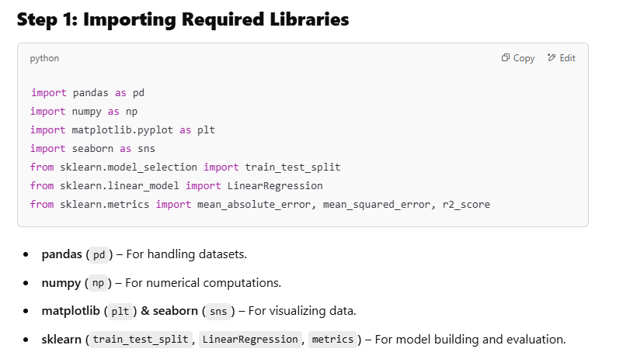

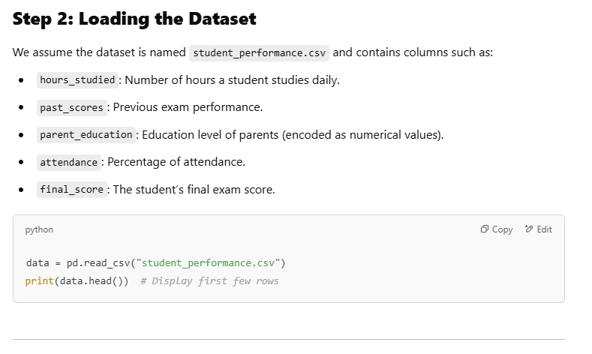

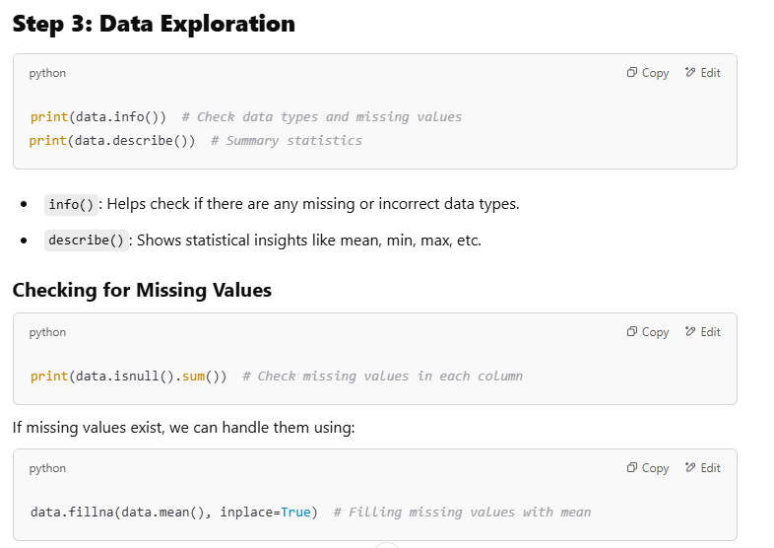

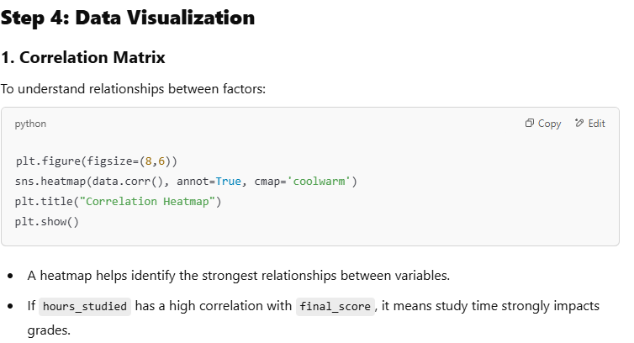

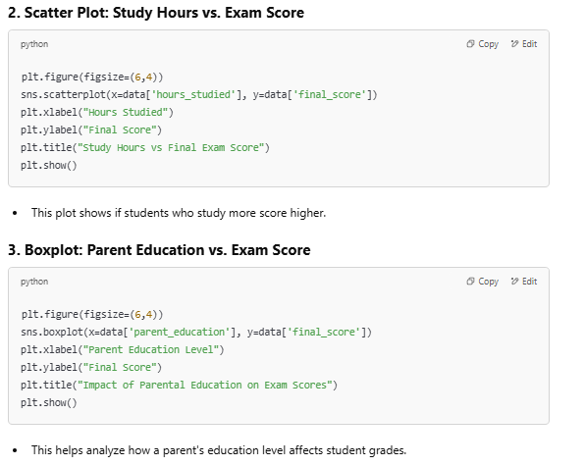

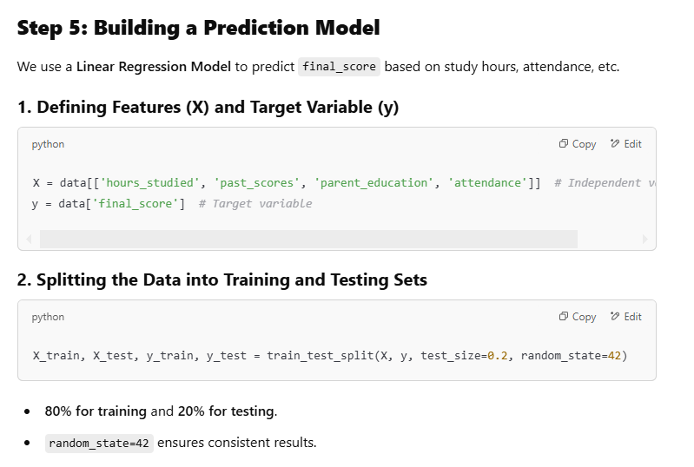

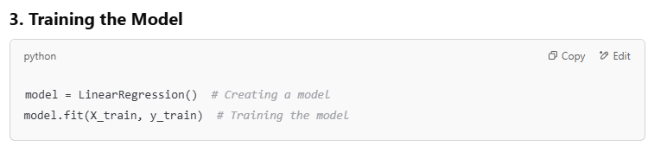

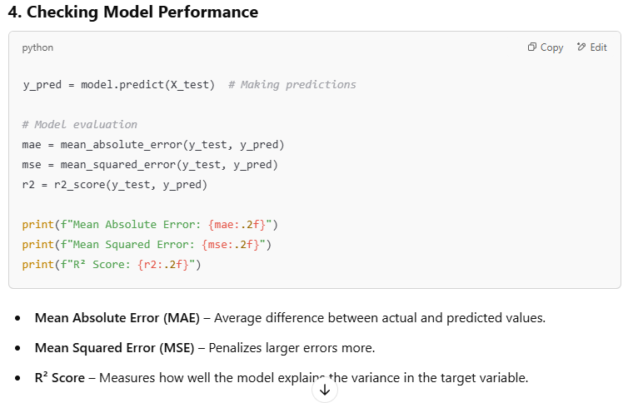

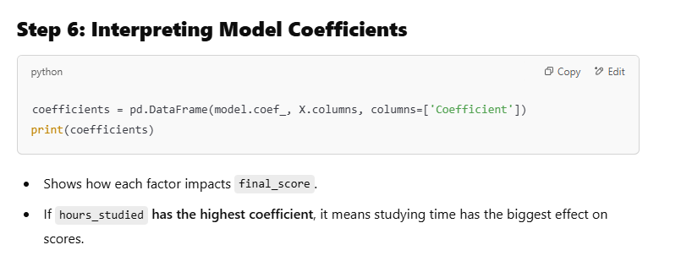

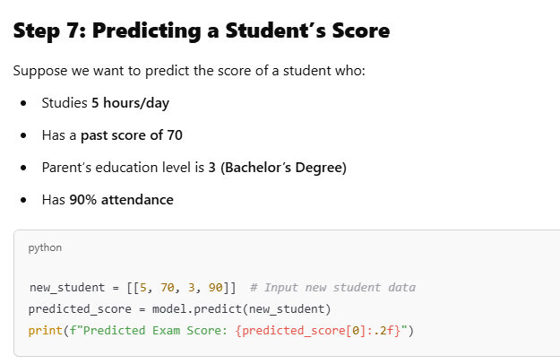

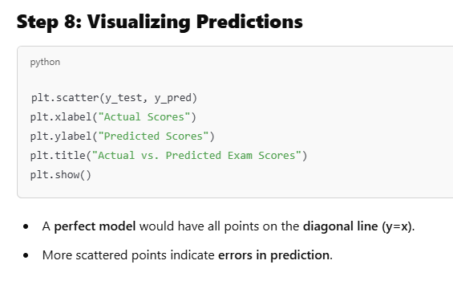

**Summary**

**What We Did in This Project?**

✅ **Loaded and cleaned** student exam performance data.  
✅ **Explored relationships** between factors affecting student grades.  
✅ **Built a Linear Regression Model** to predict exam scores.  
✅ **Evaluated model performance** using error metrics.  
✅ **Predicted scores for new students** using the trained model.

You can find **Student Exam Performance datasets** from the following sources:

**1. Kaggle (Best Source)**

Kaggle has multiple datasets on student performance. You can download them for free after signing in.

* **Example Dataset**: Student Performance Dataset
* **Contains**: Gender, parental education, test preparation course, study hours, and exam scores.

**2. UCI Machine Learning Repository**

* **Dataset URL**: [Student Performance Dataset](https://archive.ics.uci.edu/ml/datasets/student+performance)
* **Contains**: Student grades, study time, school type, parental status, absences, etc.

**3. Google Dataset Search**

* You can search for "student exam performance dataset" on Google Dataset Search.

**4. Open Government Data Portals**

* Some educational institutions and governments provide datasets related to student performance.
* Example: [data.gov](https://www.data.gov/) (for U.S. education data).

**5. Generate Synthetic Data (If no dataset fits)**

If you don’t find a suitable dataset, you can **generate synthetic data** using Python:

import pandas as pd

import numpy as np

np.random.seed(42)

# Generating synthetic student performance data

num_students = 200

data = {

'hours_studied': np.random.randint(1, 10, num_students),

'past_scores': np.random.randint(40, 100, num_students),

'parent_education': np.random.randint(1, 5, num_students),

'attendance': np.random.randint(50, 100, num_students),

'final_score': np.random.randint(40, 100, num_students)

}

df = pd.DataFrame(data)

df.to_csv("C:/Users/HP/Documents/student_performance.csv", index=False)

print("Synthetic dataset created successfully!")

This will generate **200 random student records** and save them as student_performance.csv.

**E-Commerce: Dynamic Pricing in Uber & Ola**

**1. The Problem:**

Traditional taxi services operated on fixed fare systems, often leading to inefficiencies in supply-demand balance. Uber and Ola needed a **real-time pricing strategy** to:

* Optimize fare prices based on demand and supply.
* Reduce customer wait times.
* Increase driver earnings and availability.
* Improve overall customer experience.

**2. Solution: Surge Pricing with Dynamic Pricing Models**

Uber and Ola implemented **dynamic pricing algorithms**, often called **"Surge Pricing"**, which adjust fares in real time based on multiple factors.

**How It Works?**

The pricing model considers:

1. **Demand vs. Supply:** If more users request rides than available drivers, prices increase to balance demand and attract more drivers.
2. **Time of Day & Traffic Conditions:** Higher prices during peak hours (rush hours, weekends, holidays, late nights).
3. **Location-Based Pricing:** High-demand zones (airports, city centers) have different pricing compared to low-demand areas.
4. **Competitor Pricing & Market Trends:** Algorithms compare prices with competitors (like Ola vs. Uber) and adjust accordingly.
5. **Weather Conditions:** Rainy or extreme weather conditions lead to higher fares due to fewer available drivers.

**3. Machine Learning & AI in Dynamic Pricing**

Uber and Ola use **machine learning models** to predict price fluctuations dynamically.

* **Regression Models:** Predict price changes based on demand/supply fluctuations.
* **Deep Learning & Reinforcement Learning:** Continuously improve pricing strategies based on historical ride patterns.
* **Real-time Data Processing:** Uses AI-driven decision-making to adjust fares in milliseconds.

For example, Uber’s **ML model** forecasts the number of ride requests per minute in different areas and adjusts prices instantly to match.

**4. Impact of Dynamic Pricing**

✅ **For Customers:**

* Fair pricing during off-peak hours.
* Better availability of rides in high-demand situations (at a premium cost).

✅ **For Drivers:**

* Higher earnings during peak hours.
* Encourages more drivers to be on the road when demand is high.

✅ **For Companies (Uber/Ola):**

* Maximizes revenue with **optimized pricing**.
* Balances demand and supply efficiently.
* Enhances customer satisfaction and ride availability.

**5. Challenges & Controversies**

🚨 **Customer Complaints:** Users sometimes feel "surge pricing" is unfair, especially during emergencies.  
🚨 **Regulatory Issues:** Some governments have **restricted surge pricing** to protect customers.  
🚨 **Ethical Concerns:** Pricing manipulation in disasters or crises is a major concern.

Despite these challenges, **dynamic pricing has become a crucial strategy** in modern e-commerce and ride-sharing platforms.

**Research Directions in Dynamic Pricing for Ride-Sharing Platforms (Uber & Ola)**

Dynamic pricing is a rapidly evolving area in data science, AI, and economics. Here are some key **research directions** that can drive future innovations:

**1. Fairness & Ethical Pricing**

🚀 **Challenge:** Surge pricing often leads to user dissatisfaction and accusations of price gouging.  
🔬 **Research Focus:**

* **Fairness-aware algorithms** to ensure balanced pricing for different user groups.
* **Regulatory-compliant dynamic pricing** models to prevent unethical fare hikes.
* **AI-driven sentiment analysis** to adjust pricing based on user feedback.

📌 **Example:** Developing a pricing model that limits surge rates during natural disasters or emergencies.

**2. Reinforcement Learning for Real-Time Pricing**

🚀 **Challenge:** Traditional machine learning models may not adapt well to unpredictable demand shifts.  
🔬 **Research Focus:**

* **Deep Reinforcement Learning (DRL)** for adaptive price optimization.
* **Multi-agent reinforcement learning** to balance driver supply and customer demand.
* **Personalized dynamic pricing** using customer behavior patterns.

📌 **Example:** Uber’s AI-driven pricing system continuously learns from ride patterns to optimize fares dynamically.

**3. Explainable AI (XAI) for Pricing Transparency**

🚀 **Challenge:** Users often don’t understand why surge pricing occurs.  
🔬 **Research Focus:**

* **Developing interpretable pricing models** that explain price fluctuations in real-time.
* **AI-driven justifications** for pricing changes (e.g., showing demand-supply heatmaps to customers).
* **User trust models** to analyze and reduce resistance to dynamic pricing.

📌 **Example:** A transparent pricing system that explains to users why a ride costs more at a given time.

**4. Personalized & Context-Aware Pricing**

🚀 **Challenge:** Generic surge pricing may not work for all customers.  
🔬 **Research Focus:**

* **User-specific price optimization** based on ride history, preferences, and urgency.
* **Context-aware pricing** (e.g., offering discounts to daily commuters, corporate users, or students).
* **Behavioral economics integration** to study how users react to different pricing models.

📌 **Example:** A system where loyal customers get reduced surge pricing while occasional users pay a higher rate.

**5. Multi-Modal Transportation Integration**

🚀 **Challenge:** Ride-sharing platforms must integrate with public transport for optimal pricing.  
🔬 **Research Focus:**

* **Multi-modal dynamic pricing models** (combining cabs, metro, buses, and bike rentals).
* **Smart city transport optimization** using IoT and AI.
* **Incentive-based pricing models** to promote shared rides or eco-friendly travel.

📌 **Example:** Dynamic pricing that suggests cheaper metro or bus routes if surge pricing is too high.

**6. Demand Forecasting with Advanced AI**

🚀 **Challenge:** Current models struggle with sudden demand spikes (e.g., concerts, sporting events).  
🔬 **Research Focus:**

* **Spatio-temporal demand forecasting** using deep learning and big data.
* **Event-based surge prediction models** integrating social media and calendar data.
* **Generative AI models** to simulate pricing under various demand scenarios.

📌 **Example:** AI predicting high demand near a stadium before a game and adjusting prices **before** the surge occurs.

**7. Blockchain & Decentralized Pricing Models**

🚀 **Challenge:** Pricing decisions are centralized, leading to trust issues.  
🔬 **Research Focus:**

* **Blockchain-based dynamic pricing** for greater transparency.
* **Decentralized ride-sharing platforms** where drivers and riders negotiate prices.
* **Smart contract-based fare agreements** for reducing platform commission fees.

📌 **Example:** A blockchain-powered Uber alternative where riders and drivers agree on fares without intermediaries.

**8. Carbon Footprint-Based Pricing (Green AI in Ride-Sharing)**

🚀 **Challenge:** Dynamic pricing doesn’t factor in environmental impact.  
🔬 **Research Focus:**

* **Sustainable pricing models** that offer discounts for EVs and carpooling.
* **AI-based carbon footprint tracking** to promote eco-friendly ride options.
* **Government incentive integration** for lower fares on green vehicles.

📌 **Example:** A model that offers discounts for shared rides or EV-based trips to reduce carbon emissions.

**9. Adversarial Attack Detection in Pricing Models**

🚀 **Challenge:** Surge pricing can be manipulated by artificial demand (e.g., multiple users requesting and canceling rides).  
🔬 **Research Focus:**

* **Adversarial AI detection models** to prevent ride-booking fraud.
* **AI-driven anomaly detection** for identifying sudden unnatural demand spikes.
* **Cybersecurity-integrated pricing models** to prevent tampering.

📌 **Example:** Detecting and blocking fraudulent surge pricing triggers caused by mass ride cancellations.

**Conclusion**

Dynamic pricing is a critical research area in AI, transportation, and economics. Future research should focus on making pricing:  
✅ **Fair** (reducing user frustration)  
✅ **Transparent** (explainable AI models)  
✅ **Sustainable** (green AI integration)  
✅ **Resistant to fraud** (blockchain and adversarial AI detection)

**Personalized & Context-Aware Pricing in Ride-Sharing (Uber & Ola)**

**🚀 The Challenge: Why Generic Surge Pricing Fails?**

Traditional **surge pricing** applies the same fare increase to all users in a high-demand area, regardless of their ride history, urgency, or personal circumstances. This leads to:

* **User dissatisfaction** – Frequent riders feel penalized despite their loyalty.
* **Unfair experiences** – Students or daily commuters pay the same surge fare as occasional or luxury users.
* **Missed revenue opportunities** – Some users may be willing to pay more based on urgency, while others need incentives to continue using the service.

💡 **Solution?** Personalized & Context-Aware Pricing models that tailor ride fares **dynamically** based on user data, behaviors, and real-time context.

**🔬 Research Focus Areas in Personalized & Context-Aware Pricing**

**1. User-Specific Price Optimization**

👉 **Goal:** Adjust ride fares based on each user's **ride history, preferences, and urgency.**

🧠 **How?**

* **Ride History-Based Pricing** – Frequent riders receive loyalty-based discounts.
* **Urgency-Based Pricing** – Users in a rush (e.g., booking last-minute to an airport) may pay slightly higher fares.
* **Behavior-Based Learning** – AI analyzes how a user reacts to previous price changes and tailors pricing accordingly.

📌 **Example:**

* A daily commuter using Ola/Uber 20 times a month gets a 10% discount on peak-hour fares.
* A tourist who rarely books rides may not get the same discount.

**2. Context-Aware Pricing**

👉 **Goal:** Adjust pricing based on real-world **contextual factors** like user type, time of day, and trip purpose.

🧠 **How?**

* **Time-Based Personalization:** Lower fares for students & office-goers during peak hours.
* **Corporate vs. Personal Pricing:** Business users on company accounts may get premium pricing, while regular users receive discounts.
* **Location-Based Adjustments:** Rides from areas with lower average income could have more stable pricing.

📌 **Example:**

* A student traveling from a university campus gets a **student discount** automatically.
* A corporate employee traveling to an airport from a business district gets **higher priority rides** but at premium fares.

**3. Behavioral Economics Integration**

👉 **Goal:** Use behavioral science to understand how **users react to different pricing models** and maximize engagement.

🧠 **How?**

* **Price Anchoring:** Show a "usual fare" vs. "discounted personalized fare" to make the user feel they are getting a deal.
* **Loss Aversion Pricing:** Provide a "locked-in discount" if users pre-book rides in advance.
* **Experimentation via A/B Testing:** Test different surge pricing strategies on different user groups and analyze responses.

📌 **Example:**

* Uber might offer a **"book now and save 10%"** discount if a user pre-schedules a ride for later instead of waiting until peak hours.
* Ola could notify users: **"You saved ₹50 because of your loyalty discount!"**, making them feel rewarded.

**🔍 Technical Implementation: How Can We Achieve This?**

**1. Machine Learning for User Segmentation**

Use **unsupervised learning (clustering algorithms)** to classify users into groups based on ride frequency, spending patterns, and urgency.

* **K-Means Clustering:** To segment users into daily commuters, occasional users, and tourists.
* **Hierarchical Clustering:** To detect hidden user behavior patterns.

📌 **Example:**  
A model might identify that **office commuters** and **students** should be offered different fare discounts compared to **high-income business travelers**.

**2. Reinforcement Learning for Real-Time Pricing**

A **Reinforcement Learning (RL) model** can learn **optimal pricing strategies** by continuously adjusting fares based on user responses.

* **State:** Current demand, user type, trip urgency, etc.
* **Action:** Adjust pricing up/down or offer incentives.
* **Reward:** Whether the user accepts the ride or not.

📌 **Example:**  
If a user **frequently declines rides due to high surge pricing**, the RL model may **offer a lower price** the next time to retain them.

**3. Context-Aware Pricing with Knowledge Graphs**

* Build a **knowledge graph** that connects user behavior with real-world context (events, location, urgency, etc.).
* Use **Graph Neural Networks (GNNs)** to recommend **context-specific pricing strategies**.

📌 **Example:**

* A **concert in Bangalore** is expected to increase demand.
* Users **near the event** get **higher surge pricing**, but **loyal users get a reduced surge rate** to reward their consistency.

**🎯 Expected Benefits of Personalized Pricing**

✅ **Higher User Retention** – Users feel valued and are more likely to stick to one ride-hailing app.  
✅ **Better Revenue Optimization** – Dynamic pricing maximizes revenue **without losing users to competitors**.  
✅ **Improved Customer Satisfaction** – Transparency in pricing leads to a **better user experience** and trust.

**🚀 Future Research Opportunities in Personalized Pricing**

💡 **Bias & Fairness:** Ensuring personalized pricing does not discriminate based on gender, race, or income level.  
💡 **Privacy-Preserving AI:** Using **federated learning** to personalize pricing without exposing user data.  
💡 **Blockchain for Pricing Transparency:** Ensuring **surge pricing decisions are verifiable** and not manipulated.

**Conclusion**

Personalized & Context-Aware Pricing is the **next evolution** of ride-sharing economics. By leveraging **AI, behavioral science, and context-aware algorithms**, companies like Uber & Ola can:  
✅ **Reduce user frustration with fairer pricing.**  
✅ **Optimize demand-supply without excessive surges.**  
✅ **Encourage loyalty by offering targeted discounts.**

**Proposal Structure & Technical Details**

**1️Title & Abstract**

**Title:** *"AI-Powered Personalized & Context-Aware Surge Pricing Model for Ride-Sharing Platforms"*

**Abstract:**  
Traditional surge pricing models in ride-sharing platforms (e.g., Uber, Ola) apply uniform fare increases, leading to **user dissatisfaction** and **missed revenue opportunities**. This research proposes an **AI-driven personalized pricing model** that adapts fares based on user behavior, ride urgency, and real-time context. Using **clustering algorithms, reinforcement learning (RL), and graph neural networks (GNNs)**, the proposed system will offer **fairer, data-driven pricing**, improving both **customer retention** and **profitability**.

**2️ Introduction (Problem Statement & Motivation)**

🚗 Ride-sharing companies rely on **dynamic pricing models** to balance **supply and demand**.  
❌ Current pricing models apply the **same surge rates to all users**, leading to:

* **Unfair pricing** for loyal customers & daily commuters.
* **Low retention** as users switch to competitors due to price dissatisfaction.
* **Inefficient revenue optimization**, ignoring user-specific willingness to pay.

✅ This research aims to introduce a **Personalized Pricing Model (PPM)** that:

* Uses **machine learning & reinforcement learning** to **customize ride fares** dynamically.
* Integrates **context-awareness** by analyzing location, user history, demand, and urgency.
* Optimizes **fairness** while **maximizing revenue & driver availability**.

**3️ Literature Review**

📌 **Existing Methods & Gaps:**

| **Approach** | **Techniques Used** | **Limitations** |
| --- | --- | --- |
| Rule-Based Pricing | Fixed surge multiplier | Not adaptive to user preferences |
| Demand-Supply Models | Regression, time-series forecasting | Ignores user history & urgency |
| Reinforcement Learning Pricing | Q-learning, DDPG | No personalization per user |

🔬 **Gap in Research:**  
✔️ Need for **personalized dynamic pricing** using AI.  
✔️ **Behavioral economics** and **user segmentation** are underexplored.  
✔️ **Fairness & explainability** in AI pricing models are missing.

**4️ Research Objectives**

🎯 **Primary Goals:**  
1️⃣ Develop a **User-Specific Price Optimization** model using clustering and reinforcement learning.  
2️⃣ Create a **Context-Aware Pricing Model** integrating real-time **location, urgency, and demand data**.  
3️⃣ Improve **pricing transparency** with Explainable AI (XAI).

**5️ Proposed Methodology (Technical Approach)**

📌 **Overview of the AI Pipeline:**  
1️ **Data Collection & Feature Engineering**  
2️ User **Clustering for Personalized Pricing**  
3️ **Context-Aware Demand Prediction**  
4️ **Reinforcement Learning for Price Optimization**  
5️ **Explainable AI for Transparency**

**Step 1: Data Collection & Feature Engineering**

📊 **Data Sources:**

* **User Data:** Ride frequency, spending behavior, previous reactions to surge pricing.
* **Context Data:** Time of day, location, demand levels, competitor pricing.
* **External Data:** Weather conditions, major events (concerts, festivals).

🔑 **Features Used:**

| **Feature** | **Type** | **Importance** |
| --- | --- | --- |
| Ride Frequency | Numerical | Identifies loyal users |
| Urgency (Booking Delay) | Numerical | Captures willingness to pay |
| Demand-Supply Ratio | Numerical | Surge pricing trigger |
| Time of Day | Categorical | Identifies peak vs. off-peak times |

**Step 2: User Clustering for Personalized Pricing**

📌 **Clustering Model:** *K-Means, DBSCAN, or Gaussian Mixture Model (GMM)*

* Segments users into:
  + **Frequent Riders (Loyal Customers)** – Get discounted surge pricing.
  + **Occasional Users (Tourists, One-time users)** – Standard pricing.
  + **High-Value Users (Urgent Travelers)** – Premium pricing for priority rides.

**Algorithm:**

from sklearn.cluster import KMeans

import numpy as np

# Sample data: [Rides per month, Avg Fare Paid]

user_data = np.array([[30, 15], [5, 25], [20, 18], [2, 30], [10, 20]])

# Clustering users

kmeans = KMeans(n_clusters=3, random_state=42).fit(user_data)

print(kmeans.labels_) # Cluster labels

**Step 3: Context-Aware Demand Prediction**

📌 **Model Used:** *LSTM / XGBoost for time-series forecasting*

* **Predicts future demand surges** based on location, events, and weather.
* **Prevents extreme surge pricing** by optimizing supply-side incentives.

**Step 4: Reinforcement Learning for Price Optimization**

📌 **Algorithm:** *Deep Q-Learning (DQN) / Proximal Policy Optimization (PPO)*

* **State:** User type, demand level, ride urgency.
* **Actions:** Increase/decrease fare or offer a discount.
* **Reward:** Maximizing revenue while maintaining customer retention.

🛠 **Algorithm Example:**

import gym

import numpy as np

env = gym.make("PricingEnv-v0") # Custom environment for dynamic pricing

state = env.reset()

for _ in range(1000):

action = env.action_space.sample() # Select price change action

next_state, reward, done, _ = env.step(action)

if done:

break

**Step 5: Explainable AI (XAI) for Transparency**

* Uses **SHAP (SHapley Additive exPlanations)** to explain why a user received a specific price.
* Displays **pricing justification** to improve user trust.

**6️ Expected Outcomes**

✅ **Reduced user complaints on surge pricing.**  
✅ **Higher retention for frequent riders & corporate customers.**  
✅ **Improved revenue efficiency with AI-driven price tuning.**

**7️ Challenges & Ethical Considerations**

🚨 **Bias & Fairness Risks:** Ensuring AI does not discriminate against low-income users.  
🔒 **Privacy Concerns:** Using **federated learning** to prevent exposing user data.

**8️ Timeline & Resources**

📆 **Phase-wise Development:**

* **Month 1-2:** Data collection & clustering.
* **Month 3-4:** Demand forecasting models.
* **Month 5-6:** Reinforcement learning integration.

👨‍💻 **Resources Needed:** Cloud computing for model training, real-world ride-sharing datasets.

**9️ Conclusion**

🔹 A **Personalized & Context-Aware Pricing Model** can **increase fairness, revenue, and user satisfaction**.  
🔹 Combining **clustering, demand forecasting, and RL pricing** leads to optimal pricing decisions.

**Ex. No-2 -Zomato Data Analysis**

A *Zomato Analysis* data science project typically involves analyzing restaurant data from the Zomato platform to gain insights into various aspects of the food and dining industry. Here's a breakdown of how you can structure such a project:

**Project Overview**

The goal of a Zomato Analysis project is to explore restaurant data, understand customer preferences, analyze trends, and derive actionable insights for stakeholders such as restaurant owners, marketers, or food enthusiasts.

**Key Components of the Project**

**1. Data Collection**

- Gather data from Zomato’s dataset, which may include information about restaurants, user reviews, ratings, cuisines, locations, and more. This data can be obtained through APIs, web scraping, or public datasets available for analysis.

**2. Data Preprocessing**

- Clean the data by handling missing values, removing duplicates, and correcting inconsistencies. This may involve:

- Normalizing text (e.g., converting to lowercase).

- Parsing dates and times.

- Encoding categorical variables (e.g., cuisines and locations).

**3. Exploratory Data Analysis (EDA)**

- Conduct EDA to visualize and understand the data:

- Use histograms, box plots, and scatter plots to explore distributions of ratings, prices, and review counts.

- Analyze the most popular cuisines, restaurant types, and locations.

- Identify trends over time, such as the rise of certain cuisines or changes in user ratings.

**4. Sentiment Analysis of Reviews**

- Analyze user reviews to understand customer sentiment:

- Perform text preprocessing (tokenization, removing stop words).

- Use NLP techniques to classify reviews as positive, negative, or neutral.

- Visualize sentiment trends and correlate them with ratings and restaurant attributes.

**5. Feature Engineering**

- Create new features that can provide additional insights, such as:

- Rating averages per cuisine or location.

- Review scores adjusted for the number of reviews (to account for popularity).

- Time-based features to analyze trends over months or years.

**6. Predictive Modeling**

- Build predictive models to forecast restaurant ratings or customer behavior:

- Use regression models to predict ratings based on features like cuisine, location, price range, and review sentiment.

- Implement clustering algorithms (like K-Means) to segment restaurants based on characteristics (e.g., high-rated vs. low-rated).

**7. Visualization and Reporting**

- Create dashboards and visualizations to present findings:

- Use tools like Matplotlib, Seaborn, or Tableau to visualize key insights.

- Prepare a comprehensive report that details the analysis, findings, and recommendations.

**8. Insights and Recommendations**

- Derive actionable insights and recommendations for stakeholders:

- Suggest strategies for improving customer satisfaction based on sentiment analysis.

- Identify potential areas for new restaurant openings based on demand for certain cuisines.

- Recommend marketing strategies tailored to popular trends.

**Conclusion**

The Zomato Analysis project is a comprehensive data science initiative that combines data collection, cleaning, analysis, and visualization. It offers valuable insights into consumer behavior and preferences in the food industry, helping stakeholders make informed decisions based on data-driven evidence.

**Python and its following libraries are used to analyze Zomato data.**

1. [Numpy](https://www.geeksforgeeks.org/python-numpy/)– With Numpy arrays, complex computations are executed quickly, and large calculations are handled efficiently.
2. [Matplotlib](https://www.geeksforgeeks.org/python-introduction-matplotlib/)– It has a wide range of features for creating high-quality plots, charts, histograms, scatter plots, and more.
3. [Pandas](https://www.geeksforgeeks.org/pandas-tutorial/)– The library simplifies the loading of data frames into 2D arrays and provides functions for performing multiple analysis tasks in a single operation.
4. [Seaborn](https://www.geeksforgeeks.org/introduction-to-seaborn-python/)– It offers a high-level interface for creating visually appealing and informative statistical graphics.

**You can use Google Colab Notebook or Jupyter Notebook to simplify your task.**

To address our analysis, we need to respond to the subsequent inquiries:

1. Do a greater number of restaurants provide online delivery as opposed to offline services?
2. Which types of restaurants are the most favored by the general public?
3. What price range is preferred by couples for their dinner at restaurants?

**Before commencing the data analysis, the following steps are followed.**

Following steps are followed before starting to analyze the data.

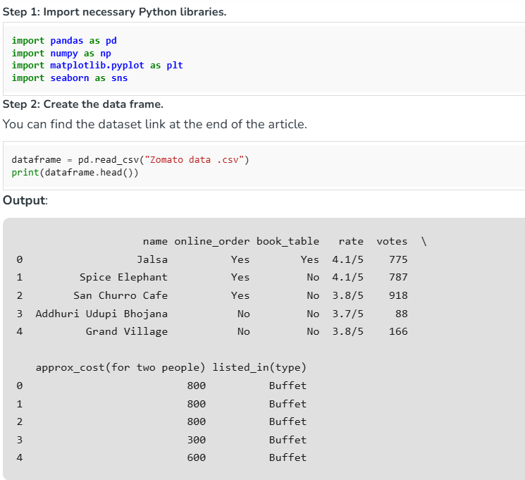

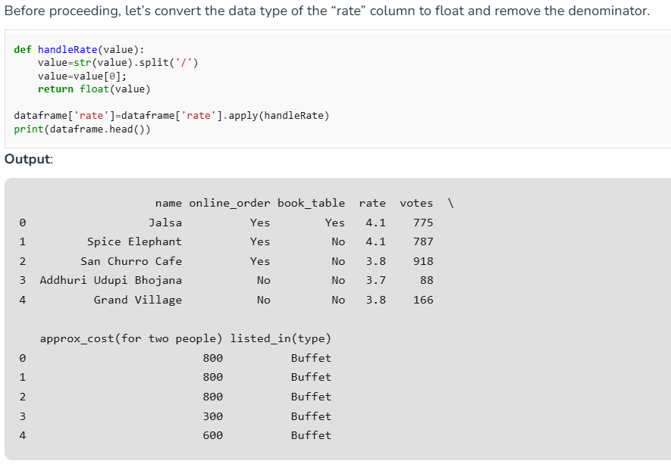

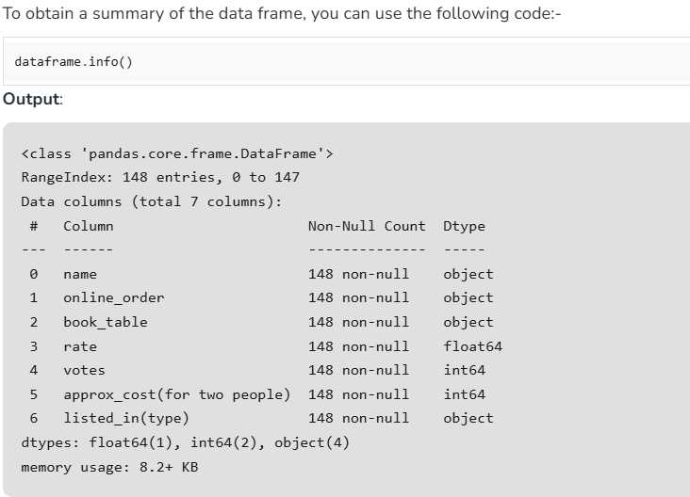

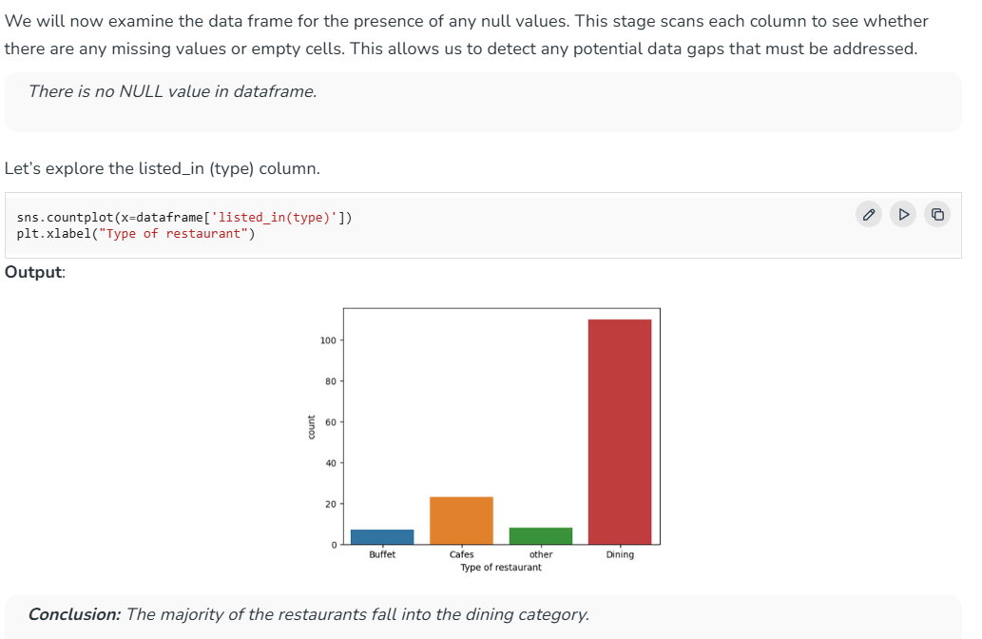

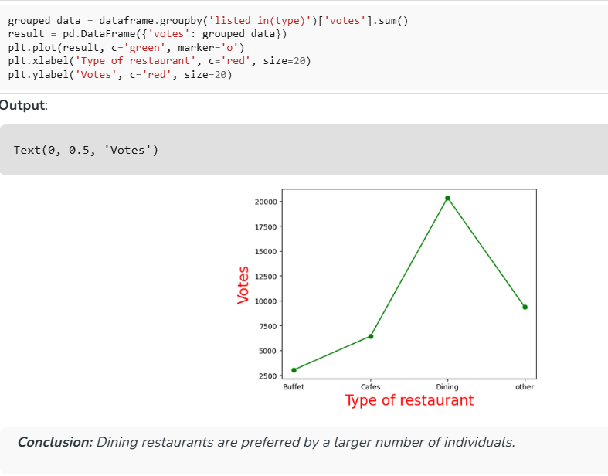

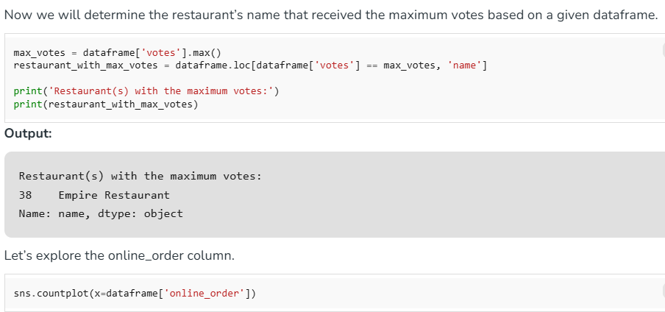

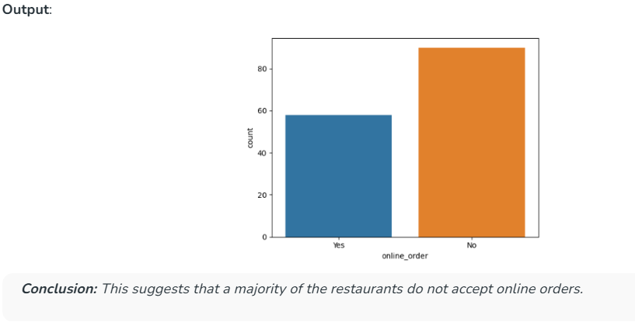

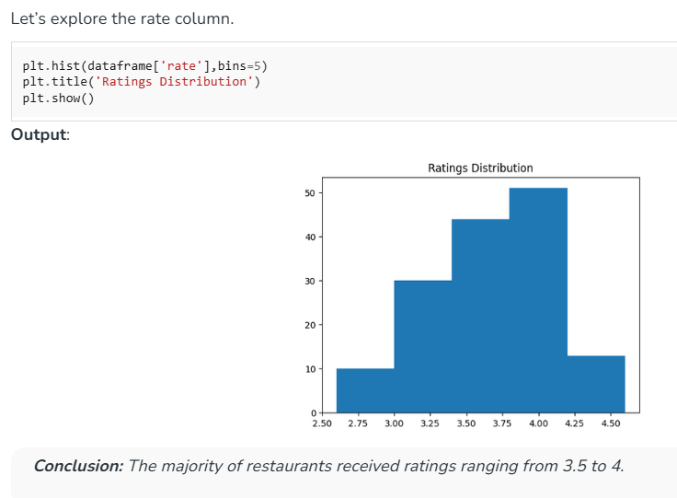

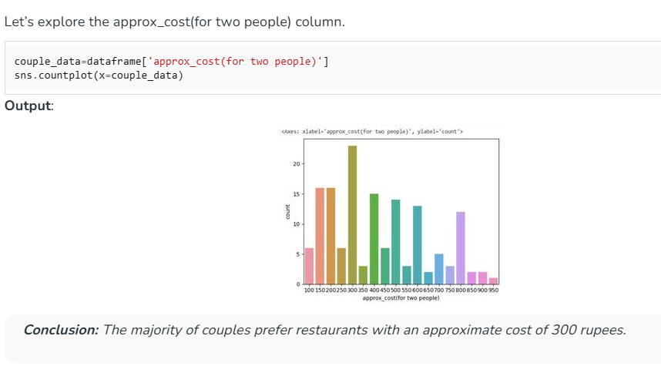

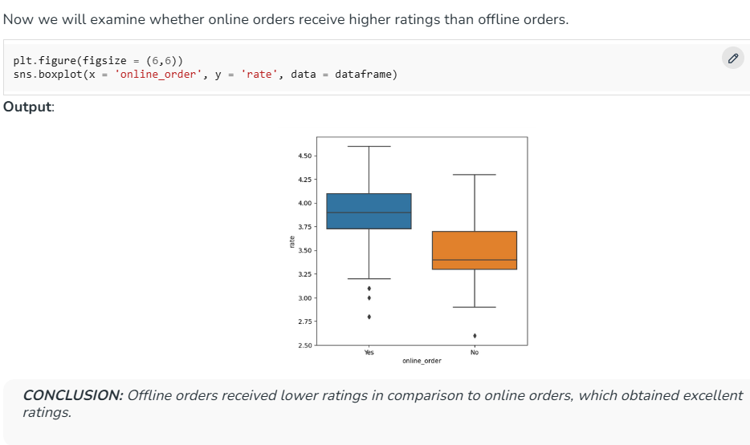

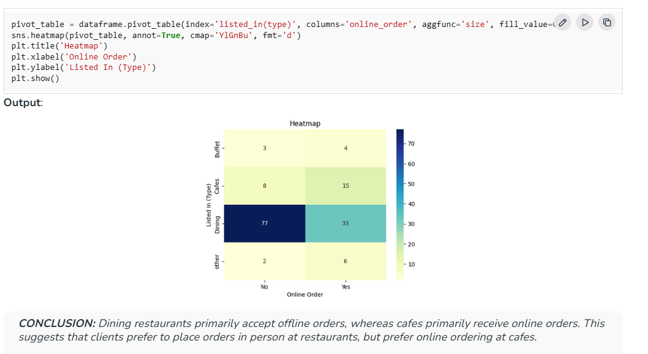

**step-by-step explanation of the Python program**

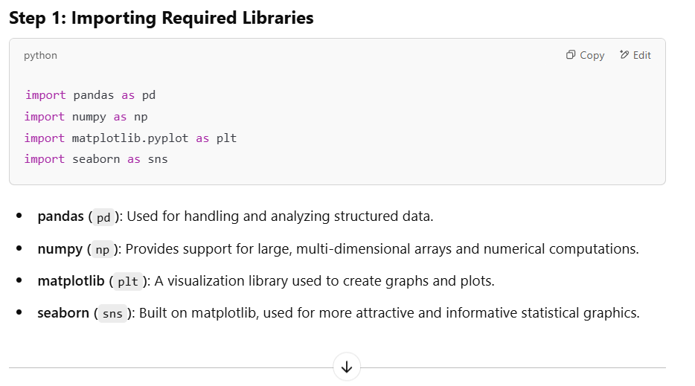

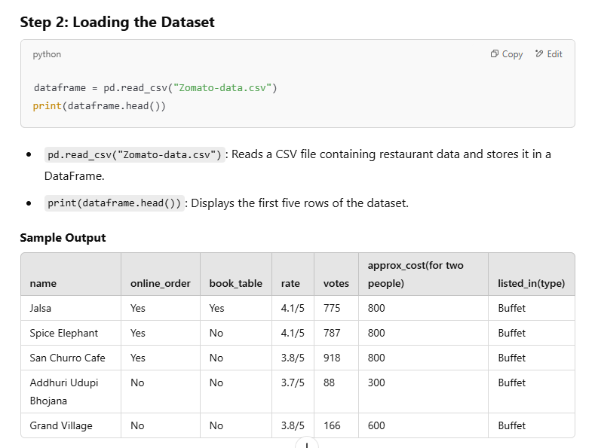

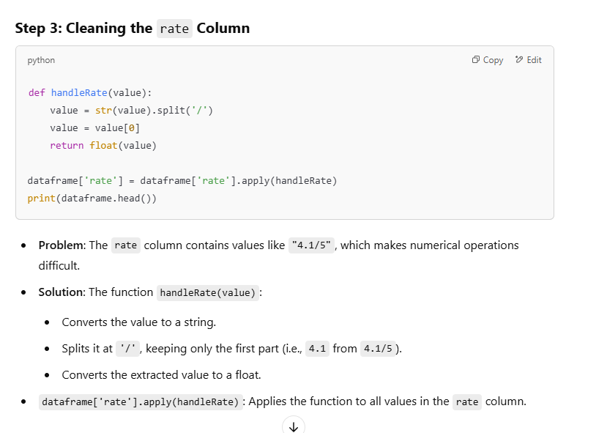

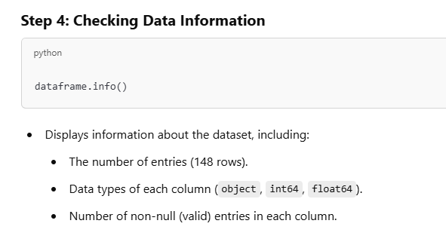

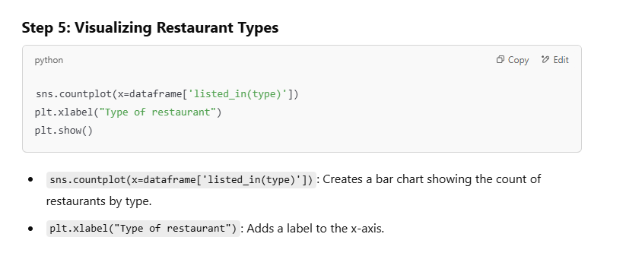

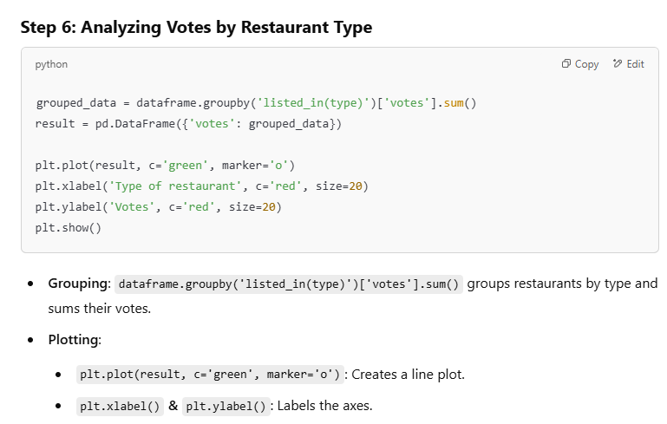

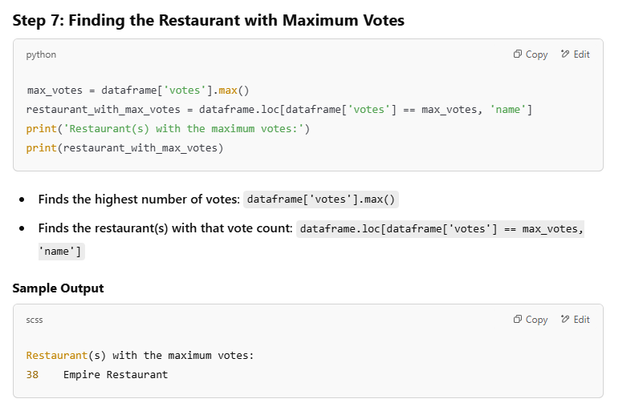

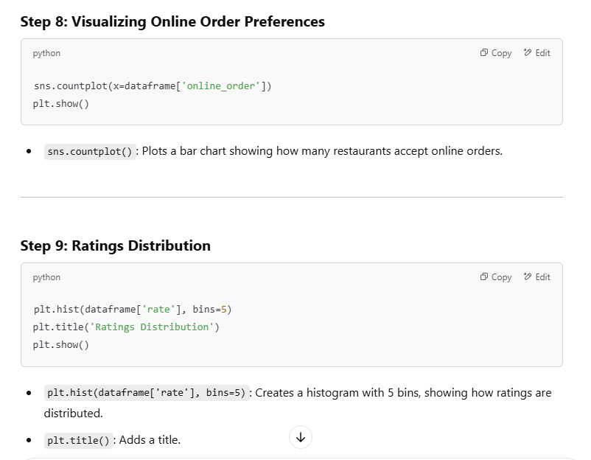

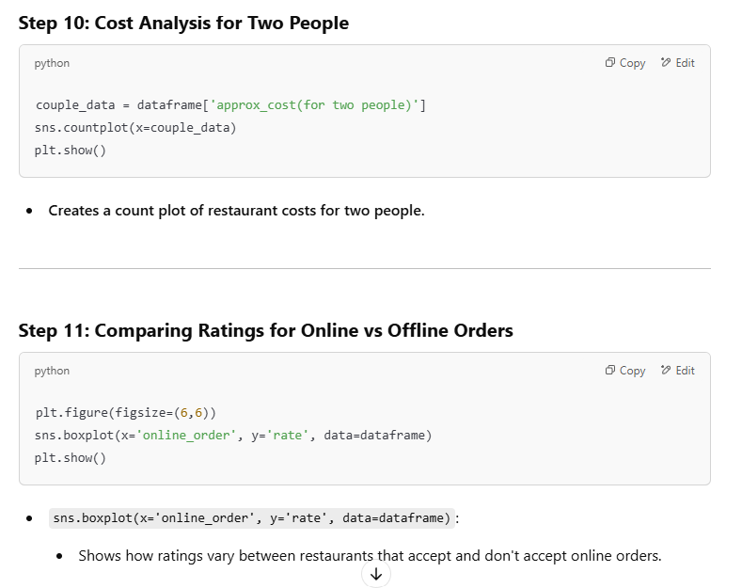

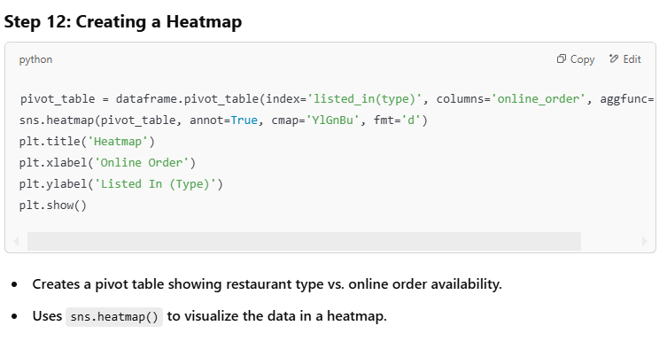

**Summary**

1. **Imported necessary libraries.**
2. **Loaded the dataset and displayed a sample.**
3. **Cleaned the rate column.**
4. **Explored and visualized the data:**
   * **Restaurant type distribution.**
   * **Votes per restaurant type.**
   * **Most voted restaurant.**
   * **Online order availability.**
   * **Ratings distribution.**
   * **Cost analysis.**
   * **Ratings comparison for online orders.**
   * **Heatmap representation.**
5. **Used pandas, matplotlib, and seaborn for data analysis and visualization.**